System Validation & Profiling Framework Documentation
1. Project Overview
This project is designed to automate the execution, validation, profiling, and reporting of different infrastructure and platform-related modules across multiple environments such as Linux, Windows, ARM, Cloud, GPU Nodes, and GPU Clusters.
The framework supports:
- Platform Profiling
- Workload Profiling
- Meta Collection
- Capacity Sizing
- Validation of Nested Keys
- Execution with and without sudo
- ZIP/UNZIP handling
- HTML Reporting
- Automated Test Case Validation
The framework is fully argument-driven using Python argparse and supports scalable execution across multiple servers and environments.

2. Folder Structure
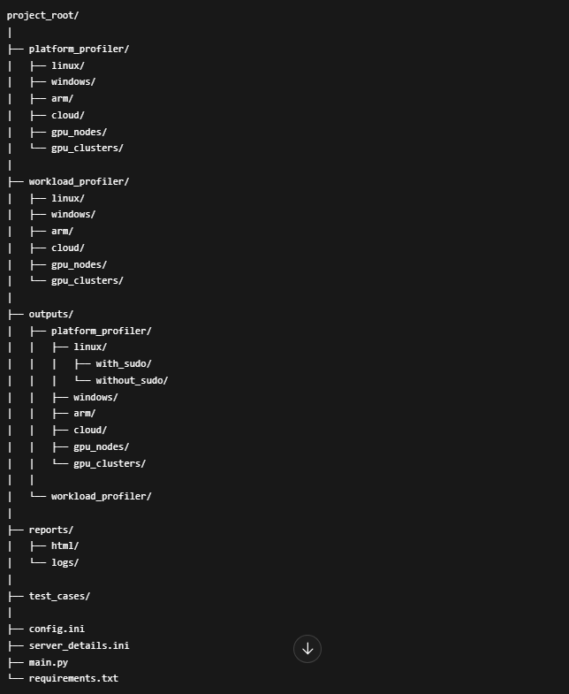

3. Module Descriptions
3.1 Platform Profiler (PP)
The Platform Profiler module is responsible for collecting and validating platform-level information from different operating systems and infrastructures.
Supported Environments:
- Linux (All Distros)
- Windows (Different Architectures)
- ARM Systems
- Cloud Platforms (AWS, Azure, GCP)
- GPU Nodes
- GPU Clusters
Responsibilities:
- OS profiling
- Hardware information collection
- BIOS details
- System architecture validation
- Platform capability checks

4. Configuration File
- File: config.ini
- This configuration file stores all endpoint URLs required for testing and execution.
- Example Structure:
[platform_profiler]
linux=https://linux-url
windows=https://windows-url
arm=https://arm-url
cloud=https://cloud-url
gpu_nodes=https://gpu-node-url
gpu_clusters=https://gpu-cluster-url
[workload_profiler]
linux=https://linux-url
windows=https://windows-url
arm=https://arm-url
cloud=https://cloud-url
gpu_nodes=https://gpu-node-url
gpu_clusters=https://gpu-cluster-url
[meta_collector]
linux=https://linux-url
windows=https://windows-url
arm=https://arm-url
cloud=https://cloud-url
gpu_nodes=https://gpu-node-url
gpu_clusters=https://gpu-cluster-url
[capacity_sizer]
linux=https://linux-url
windows=https://windows-url
arm=https://arm-url
cloud=https://cloud-url
gpu_nodes=https://gpu-node-url
gpu_clusters=https://gpu-cluster-url

Purpose:
- Centralized URL management
- Easy switching between environments
- Dynamic execution configuration

5. Server Details File
File: server_details.ini
This file stores authentication and connectivity information for all servers.
Example Structure:
[linux]
user=username
password=password
ip=192.168.1.10
[windows]
user=username
password=password
ip=192.168.1.11
[arm]
user=username
password=password
ip=192.168.1.12
[gpu_cluster]
user=username
password=password
ip=192.168.1.13
Purpose:
- SSH connectivity
- Remote execution
- Credential management
- Multi-server support

6. Main Entry Point
File: main.py
main.py acts as the primary execution entry point for the entire framework.
Execution is fully controlled using command-line arguments through Python argparse.

7. Supported Command-Line Arguments
Short Arguments
Argument | Description
-pp | Platform Profiler
-wp | Workload Profiler
-mc | Meta Collector
-cs | Capacity Sizer
-all | Execute All Modules

Help Commands
Short Help
python main.py -h
Displays:
-pp
-wp
-mc
-cs
-all

Detailed Help
python main.py --help
Displays:
-platform profiler
-workload profiler
-meta collector
-capacity sizer
-all modules

8. Key Validation Feature
The framework supports validation of deeply nested keys inside JSON payloads.
Example JSON:
{
"chassis": {
"systems": {
"bios": {
"version": "1.0" #suppose this is newly added
}
}
}
}
Key Input Format:
[chassis.systems.bios.version]
Supported Features:
- Single key validation
- Multiple key validation
- Nested dictionary traversal
- Null value validation
- Missing key validation
Validation Output:
- Key Present
- Key Missing
- Key Value is Null
Example Messages:
[PASS] Key found: chassis.systems.bios.version
[FAIL] Key missing: chassis.systems.bios.version
[FAIL] Key exists but value is null

9. Sudo and Non-Sudo Execution
The framework supports both:
- Execution with sudo
- Execution without sudo
Purpose:
- Privileged command validation
- Non-privileged environment testing
- Security validation
Output directories are separated accordingly.
Example:
outputs/platform_profiler/linux/with_sudo/
outputs/platform_profiler/linux/without_sudo/

10. Output Management
All execution outputs are stored in structured directories.
Output Categories:
- Platform Profiler Outputs
- Workload Profiler Outputs
- Meta Collector Outputs
- Capacity Sizer Outputs
Environment Categories:
- Linux
- Windows
- ARM
- Cloud
- GPU Nodes
- GPU Clusters
Execution Modes:
- With Sudo
- Without Sudo

11. ZIP and UNZIP Handling
The framework supports:
- Automatic ZIP creation
- Output compression
- ZIP extraction
- Archive validation
Purpose:
- Reduce storage usage
- Easy transfer of outputs
- Backup management
Supported Operations:
- Create ZIP
- Extract ZIP
- Validate ZIP contents
- Read outputs from ZIP archives

12. Test Case Validation
A dedicated test_cases module is included for validating all functionalities.
Test Coverage:
- Argument validation
- URL validation
- Server credential validation
- Key validation
- JSON traversal
- ZIP/UNZIP validation
- Output validation
- HTML report validation
Purpose:
- Ensure reliability
- Preventing failures
- Improve maintainability

13. HTML Reporting System
The framework generates detailed HTML reports after execution.
Features:
- Execution summary
- Pass/Fail statistics
- Environment-wise results
- Failure reasons
- Validation details
- Timestamp tracking
Example:
Linux Servers:
Total Servers: 10
Passed: 9
Failed: 1
Failure Details Example:
Server IP: 192.168.1.20
Failure Reason:
- BIOS key missing
- SSH authentication failed
- URL unreachable
Report Sections:
- Summary Dashboard
- Environment Results
- Validation Logs
- Error Reports
- Execution Metrics

